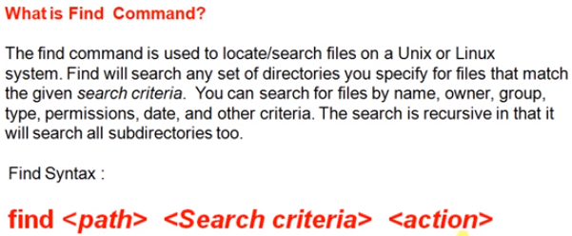

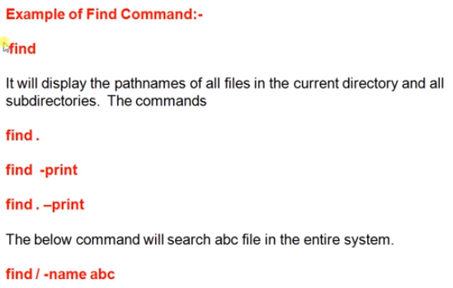

* **Find -type f** 🡪 displays only the files
* **Find -type d** 🡪 displays only the directories
* **Find . -type f -name abc.txt** 🡪 here it finds the files which contains name as abc.txt in current directory
* **Find . -type f -iname abc.txt** 🡪 this one also works as same as above, but it finds both cases of letters
* **Find . -type f -iname “*.txt** 🡪 with this, we can find all the files in current directory

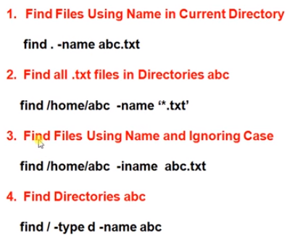

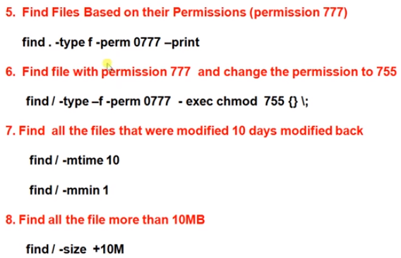

For time, we can use either use time or minutes

We can access **a** for access, **m** for modify and **c** for change time

* **Find . -type f -perm 0777 -exec chmod 755 {} \;** 🡪 with this command, we execute the chmod command to change the permissions to the file which found with find command
* **Find . -mtime +1** 🡪 it finds the files which are modified more than 1 day
* **Find . -mtime -1** 🡪 it finds the files which are modified less than 1 day
* **Find . -type f -mtime -2 -exec rm -f {} \;** 🡪 this deletes the files which are modified in less than 2 days
* **Find . -mmin +1 -mmin -3** 🡪 here it finds the files modified more than 1 min and less than 3 mins

Find actually finds from all the current directory

If we want to restrict that. Use as below

* **Find . -maxdepth 1 -name abc.txt** 🡪 with this, it finds only from the current directory
* **Find . -maxdepth 10 -name abc.txt** 🡪 it goes depth up to 10 sub directories

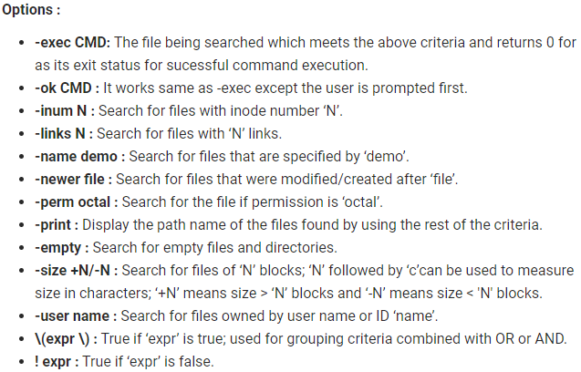

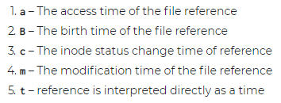

**To filter with date:**

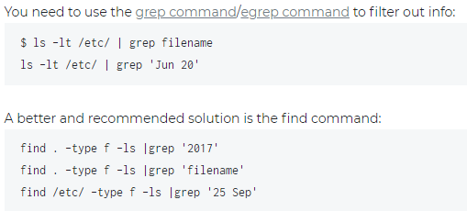

* As above, we can filter it with the date name also

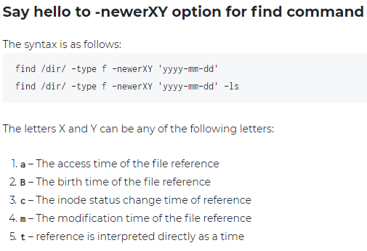

* As above also we can use to filter with exact date
* At the end, we can use it even without -ls. But if we use -ls, it will display the files with all the information

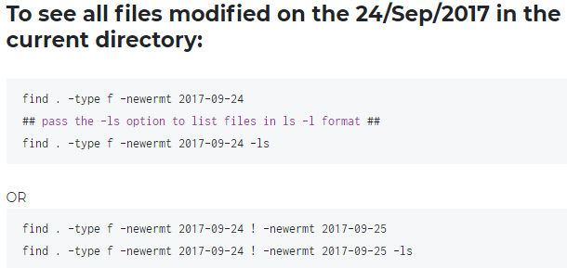

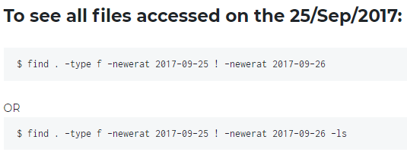

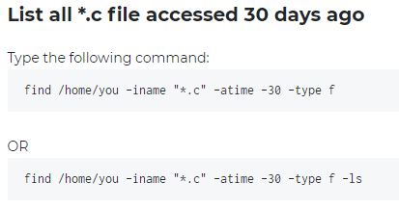

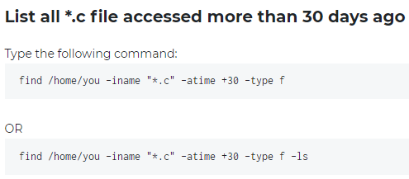

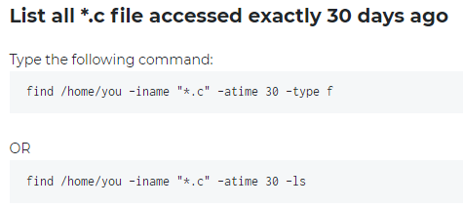

**Excluding files or directories:**

